KOOLB

Vision Document

Version 0.1

Revision History

| **Date** | **Version** | **Description** | **Author** |
| --- | --- | --- | --- |
| 12/11/22 | 1.0 | Fulfill the detailed information of vision document (including from section 1 to section 6) | Linh, Vy, Khánh |
| 26/11/22 | 1.1 | Update section 5 | Linh, Vy, Khánh |
|  |  |  |  |
|  |  |  |  |

Table of Contents

**1. Introduction** **4**

1.1 Purpose 4

1.2 Scope 4

1.3 References 4

**2. Positioning** **4**

2.1 Problem Statement 4

2.2 Product Position Statement 4

**3. Stakeholder and User Descriptions** **5**

3.1 Stakeholder Summary 5

3.2 User Summary 5

3.3 User Environment 6

3.4 Summary of Key Stakeholder or User Needs 7

3.5 Alternatives and Competition 8

**4. Product Overview** **9**

4.1 Product Perspective 9

4.2 Assumptions and Dependencies 10

4.3 Summary of capabilities 10

**5. Product Features** **12**

**6. Non-Functional Requirements** **13**

Vision (Small Project)

# Introduction

## Purpose

The purpose of this document is to define the high-level requirements of a hotel booking app - KOOLB in terms of the needs of the end users.

## Scope

This Vision Document applies to KOOLB hotel booking app, which will be developed by Group 01.

This application will enable hosts who want to rent their hotel, homestay or hostel to post information about these services on the app. KOOLB app also allows renters to find and book accommodation in case they have demand.

## References

Applicable references are:

1. Slide
2. Instruction video

# Positioning

## Problem Statement

| **The problem of** | renting and looking for a hotel/homestay when traveling |
| --- | --- |
| **affects** | hosts who rent housing services and travelers who look for shelters / some places to sleep over |
| **the impact of which is** | - hosts who hardly make ends meet or want to have an extra source of income  - renters who pay high prices for housing services but do not know whether they are good enough or not and those who struggle to find accommodation while traveling |
| **a successful solution would be** | Hosts: Opportunity to promote their services  Renters: Convenience in looking for a suitable accommodation to stay over |

## Product Position Statement

| **For** | hosts, renters |
| --- | --- |
| **Who** | renting/booking a hotel/homestay/accommodations |
| **The (product name)** | KOOLB |
| **That** | Allow hosts to promote their rental services, earn extra money and provide travelers with reasonably priced accommodation. |
| **Unlike** | The current distributions of Booking.com |
| **Our product** | Concentrate primarily on accommodations with specific information and features while strictly verifying identities to maintain trust between renter and host. |

# Stakeholder and User Descriptions

## Stakeholder Summary

| **Nameme** | **RepresentsiptReion** | **Role** |
| --- | --- | --- |
| Development Team | Students as members in Group 01 | Develop and maintain the application. |
| Ms.Nguyen Thi Minh Tuyen | Professor | Instruct and supervise the project development process. |
| Renter (user and stakeholder) | Renters | Ensures that the application will meet the needs of renters |
| Host (user and stakeholder) | Hosts | Ensures that the application can assist the hosts with requirements about promoting their housing services. |

## User Summary

| **Name** | **Represents** | **Role** | **Stakeholder** |
| --- | --- | --- | --- |
| Admins | Students as members in Group 01 | Manage accounts, payment, and the process of booking renters and posting of hosts.  Statistics on data such as the number of bookings, ratings, the number of rooms available,...  Answer any customer’s FAQ; | The Development team |
| Hosts | Anyone who wants to rent their housing services | Post and update information, and manage the state of rooms.  Answer customers’ questions. | self-represented |
| Renters | Anyone who wants to find places to stay temporarily | Select rooms to stay.  Pay the service fee. | self-represented |

## User Environment

At least three people are completing the task which includes host, renter, and admin.

The process of posting, updating housing services and booking takes place at any time whenever the users have demand. Information about housing services posted by the host needs to be approved by admins before appearing on the application. Rooms are booked successfully after the rental fee is paid.

The users are educated, and smartphone competent. The ability to post, update information, and book accommodations via smartphone with an Internet connection.

Android, iOS, Web are system platforms that are used today.

Airbnb, Agoda, Booking.com, and Traveloka are examples of applications having similar functions that are in use.

The initial release of KOOLB will be limited to classmates. Further improvement of our app to be used among schools, colleges, and universities is under consideration.

## Summary of Key Stakeholder or User Needs

| **Need** | **Priority** | **Concerns** | **Current Solution** | **Proposed Solution** | |
| --- | --- | --- | --- | --- | --- |
| **Accommodation Booking and Discovery for travelers** | High | Travelers can not find their wanting accommodation during trip; Staying in hotel may cost a large amount of travel budget | Travelers may seek accommodations through social media platforms such as Facebook or through travel companies. | | Travelers can look for their wanted accommodation through images shown on our app and can discover with a wide variety of choices. |
| **Hosts advertising for their housing service** | High | Underrated or newly startup accommodation with potential and high-quality amenities may be hard to reach to the target users. | Hosts can advertise their accommodation through social media platforms but customers often choose high-reputation ones because of trustability, making newly startup accommodation hard to gain a position. | | Both newly found or long-standing accommodation have a chance to promote their housing services as well as reach their target users. |
| **Quick booking** | Medium | Long delay or easily occurred problems when booking accommodation offline | Customers often book their accommodation through the registration form, telephone contact, or traveling companies but these ways can take up many days or even weeks. Making any changes in the trip or suddenly occurring problems may be hard to solve. This provides customers limited flexibility in planning their scheduled journey | | Travelers will have online access to quickly book their desired accommodation or cancel the booking. |

## Alternatives and Competition

Airbnb

* Strengths:
  + High reputation
  + Offers many cheap alternatives to hotel
  + A wide variety of accommodating choices with good filtering options such as kitchens, WIFI, washer.
  + User-friendly interface
  + Hosts can submit a review and assign a star rating to guests. A guest has a star rating shown on their profile.
  + The Airbnb Instant Book function of the host used for approving rental requests can be turned on or off.
* Weaknesses:
  + Lack of quality control for hosts, some hosts charge high prices.

Agoda:

* Strengths:
  + Usually offers lower prices than its competitors because in some cases, they buy rooms directly from hotels then offer them at a competitive price.
* Weaknesses:
  + Charge foreign currency conversion fee.
  + There is plenty of false advertising on Agoda App that the actual rooms are completely different from pictures.
  + Agoda sometimes makes mistakes with room amenities.

Booking.com:

* Strengths:
  + Permits hosts to impose extra fees on guests, like cleaning and towel fees.
  + Focus on providing services for hotels, resorts, and lodges.
  + Has a cash-on-arrival payment option.
* Weaknesses:
  + Hosts can end up with difficult or misbehaving visitors due to the function of approving rental requests immediately.
  + Cancellation is less structured, depending much on hosts and guests

# Product Overview

This section provides a high-level view of KOOLB's capabilities. interfaces to system configurations.

## Product Perspective

This product is independent and self-contained (see Figure 4.1.1)

The KOOLB hotel-booking System will consist of a client component (hosts, renters) and server component as illustrated in Figure 4.1.2. The server component includes a database for users to work on. This server will not interface with any existing servers.

The client component resides on a personal mobile phone. People can download this KOOLB application on CHPlay. Once the clients have downloaded on the mobile phone, the user can get access to the KOOLB from the phone through LAN or Internet. A user identical address (Email) and password must be entered in order for access to be granted.

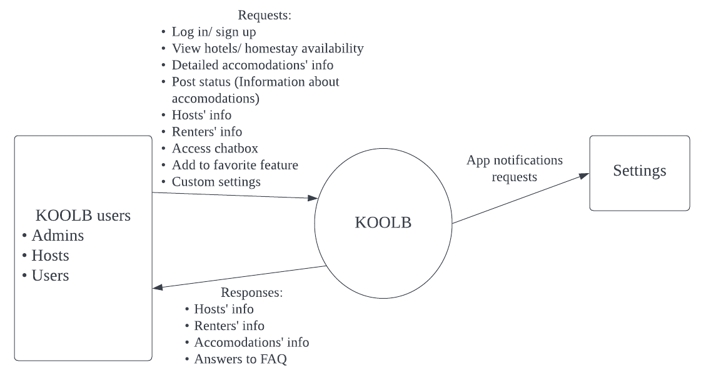

**Figure 4.1.1.** KOOLB Context Diagram

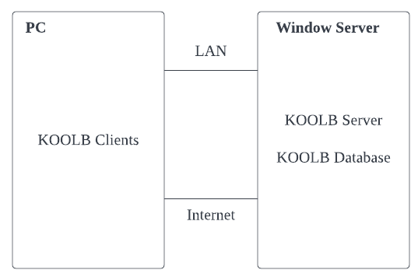

**Figure 4.1.2.** KOOLB System Overview

## Assumptions and Dependencies

* Minimum IOS version of 13.0 and minimum SDK version of 20 is required to run this app
* Our app is active 24/24
* The UI is responsive and can run smoothly on both Web and mobile devices.

## Summary of capabilities

| **Customers’ benefits** | **Supporting features** |
| --- | --- |
| Up-to-date hotel/homestay information | Hosts are required to update any feature and facility changes through editing features of the accommodation posted. |
| Easily connected to administrators | Customers can ask any question through chatbox. These questions will be answered by administrators in-app. The feature does not require an external website (FAQ in game). |
| Up-to-date Registration Information | Any users’ information inputs into the app will be immediately saved and available for usage. Any information changes during app running will also be immediately updated. |
| Access own account in any android devices or emulators at once | Users can log in their account on many devices using Android systems or android simulators. The app is always available on ChPlay. Many devices can open the same account at the same time. |
| Easily find the nearest hotel | People can use GPS to identify the current location. The app will auto-generate the nearest hotels to benefit the customers |
| Easy to keep track with renters in one accommodation | Accomodations’ owners are provided with tools to view detailed information of renters and the number of guests staying in a hotel/homestay at the moment. They can also view the statistics of the number of guest visiting, ratings… in order to keep track with the incomes. |
| Easy to find their previous bookings | When guests book any hotel through the app, their information will be saved and visible to those guests. The next time they book while heading to the location, they will find the name of that hotel in priority search.  This feature is also easier for hosts if they want to make vouchers for guests that used to stay at the accommodation. |
| Understand the price of the products in their currency | Price of one single accommodation can be converted to different currency unit |

# Product Features

| **No.** | **Feature** | **Role** | **Description** | **Priority** |
| --- | --- | --- | --- | --- |
| 1 | **Registration** | Host + Admin + Renter | The user must first create an account with your app by giving his name, email address, phone number, or both. | High |
| 2 | **User Account** | Host + Admin + Renter | It comprises the user's fundamental information, such as his name, email address, mobile phone number, booking and transaction history, wishlist, preferred language, and so on. | High |
| 3 | **Search Option** | Renter | Locating precise information about the hotel and its features. | Medium |
| 4 | **Booking and Cancellation Page** | Renter | Allow clients to reserve a room immediately after selecting it. It would include information like the check-in and check-out dates, destination or city, number of persons staying, and much more. | High |
| 5 | **Payment Gateway** | Renter | Customers may make payments through the app utilizing the available alternatives using online banking or pay with a credit or debit card. | Medium |
| 6 | **Review and Ratings** | Renter | Rating and review from customers | High |
| 7 | **Statistics and Analysis** | Host + Admin | Display the number of bookings, the changing rate, and the level of satisfaction, etc. | Medium |
| 8 | **Push Notifications** | Renter | Send quick bulk messages to a large number of registered customers about new offers, discounts, amenities, the start of any service, and so on. | Medium |
| 9 | **Chatbox** | Renter + Host | Allow users and the host to discuss more information. | High |
| 10 | **Geo-Location Facility** | Renter | The use of geo-location services will assist your clients in getting to the hotel quickly and using the shortest possible path from their point of arrival. | Low |
| 11 | **Use of Social Media Platforms** | Renter + Host | Can link to common social media platforms such as Facebook | Low |
| 12 | **City Tour Guide** | Renter | Information about locations to visit, shopping sites, local modes of transportation, and dishes to try, etc. | Low |
| 13 | **Cab and Flight Booking** | Renter | Renters are also provided cab booking and flight reservations, eliminating the need for the consumer to utilize another app. | Low |
| 14 | **Eco-UI** | Renter + Host + Admin | User-friendly, easy to use and responsive, environment-friendly | Low |
| 15 | **Sort and Filter results** | Renter | Allow renters to sort or filter the result. | Low |

# Non-Functional Requirements

* The app must be reliable and trustable in case of security by not leaking or transferring users’ private information
* The system has a high run time speed (10 transactions per sec)
* Constantly up to date for compatibility with devices
* The system should be easy to use and install for non-tech relevant users.
* Hardware cost is affordable (the software can run on a low-performance mobile phone)
* UI design is user-friendly, it is easy to learn and use
* The system’s new version update must be under 2 hours
* Quick usage guide is available for user
* System does not demand sophisticated skill